Lenna Kovalevich

Exam Two:

log.growth <- function(t, y, p) {

N <- y[1]

with(as.list(p), {

dN.dt <- r \* N \* (1- (N/K)^theta)

return(list(dN.dt))

})

}

p.tomato <- c('r' = 0.2, 'K' = 1.05, 'theta' = 1.05)

y0 <- c('N' = 0.01)

t <- 1:100

p.grapes <- c('r' = 0.28, 'K' = 0.75, 'theta' = 1.25)

y0 <- c('N' = 0.01)

t <- 1:100

p.peaches <- c('r' = 0.15, 'K' = 1, 'theta' = 1)

y0 <- c('N' = 0.01)

t <- 1:100

library(deSolve)

sim <- ode(y = y0, times=t, func = log.growth, parms = p.tomato, method

= 'lsoda')

sim <- as.data.frame(sim)

sim.2 <- ode(y = y0, times=t, func= log.growth, parms = p.grapes,

method = 'lsoda')

sim.2 = as.data.frame(sim.2)

sim.3 <- ode(y = y0, times=t, func= log.growth, parms = p.peaches,

method = 'lsoda')

sim.3 = as.data.frame(sim.3)

sim$deriv <- c(diff(sim$N), NA)

plot(deriv ~ N, data = sim, type = 'l', col = 'blue', bty ='l')

sim.2$deriv <- c(diff(sim.2$N), NA)

points (deriv ~ N, data= sim.2, type = 'l', col='purple')

class(sim.2)

sim.3$deriv <- c(diff(sim.3$N), NA)

points (deriv ~ N, data= sim.3, type = 'l', col='green')

class(sim.3)

(Did not have time to make legend)

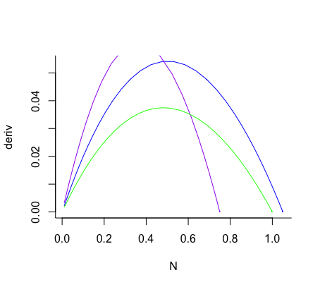

sim$N[which(sim$deriv == max(sim$deriv, na.rm = TRUE))] ##0.5299

sim.2$N[which(sim.2$deriv == max(sim.2$deriv, na.rm = TRUE))]##0.3454

sim.3$N[which(sim.3$deriv == max(sim.3$deriv, na.rm = TRUE))] #0.4762